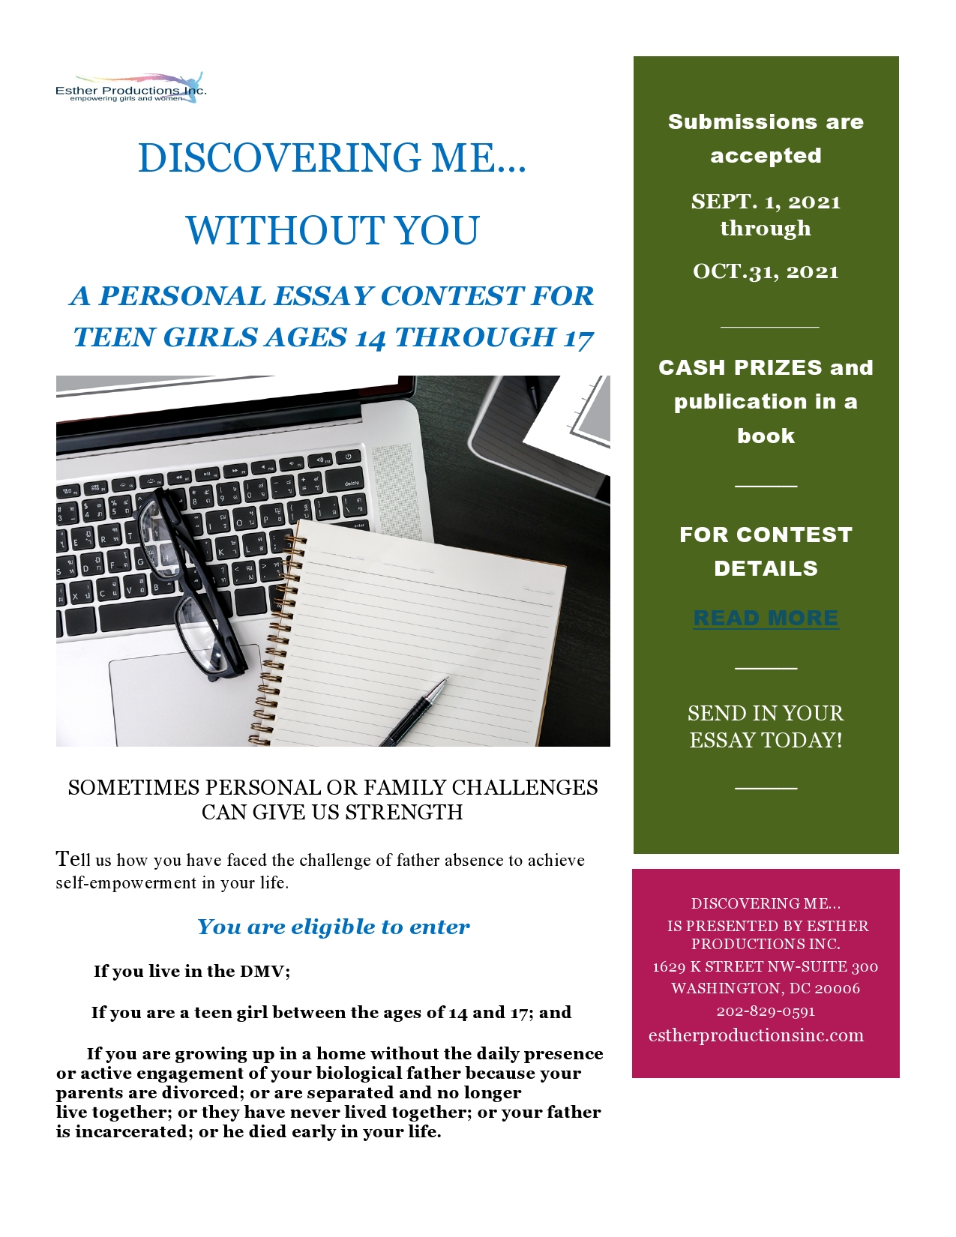

Esther Productions, Inc. is a Washington, DC-based national nonprofit organization. Founded in 2004, is dedicated to using a variety of vehicles—traditional and nontraditional—to develop communities throughout the United States and Europe. It was created in 2004 by Jonetta Rose Barras, award-winning journalist and author of Whatever Happened to Daddy’s Little Girl?
Esther Productions, Inc hosted it's 1st Annual Discovering Me..Without You Essay Contest in 2019 and it's 2nd Annual Discovering Me..Without You Essay Contest took place last year. This year, Esther Productions, Inc is hosting it's 3rd Annual Discovering Me.. Without You Essay Contest from September 1, 2021 - October 31, 2021. It is designed for teens ages 14 - 17.
CASH PRIZES WILL BE AWARDED:
Ist Place--- $1,000
2nd Place-- $500
3rd Place-- $200
Honorable Mention--$50
Top essays will be published in a book to be released Spring 2022
It is supported through generous contributions from Kerry S. Pearson LLC, Emmanuel Bailey, Veterans Services Corp, Pepco, an Exelon Corporation, Fort Myer Construction Corporation Charitable Foundation and Esther’s Friends.
The entries will be judged by a team of successful professional leaders including Ana Acevedo holds a degree in psychology and is a manager in the DC government; Patricia Bitondo is a board member of the Educational Foundation of the Woman’s National Democratic Club and a businesswoman; Ana R. Harvey is a former senior executive in President Barack Obama’s administration who focused on the development of women-owned businesses; Alicia Henry, former nonprofit executive; Winfield Swanson is Director of Communications for the Woman’s National Democratic Club; Addison Switzer is an actor and CEO of BuckWild Media; Shelley Livingston and Jerry Malmo.
CONTEST RULES:
- Essays must have a cover page with the author’s name, age, home address, email address and name of school.
- Essays must also have a title of the essay on all pages; the author's name may not appear on any page other than the cover page.
- Essays must be original and use proper citation(s); they cannot contain the words of another person without giving that individual credit within the text of the essay.
- Essays must be between 750 words and 1500 words;
- Essays must be written in English--the writer should indicate at submission if English is not her native language.
- Essays must be typed with 12- point font, doubled spaced, printed only on one side of the paper; essays may be submitted electronically either as a doc. or pdf file
For more information about the contest, visit http://www.estherproductionsinc.com/contest

